Name : Essam Khan

Roll No :17-k-3827

Section :D

Q2(Naive Bayes)

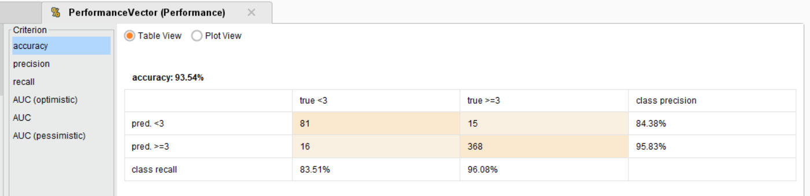

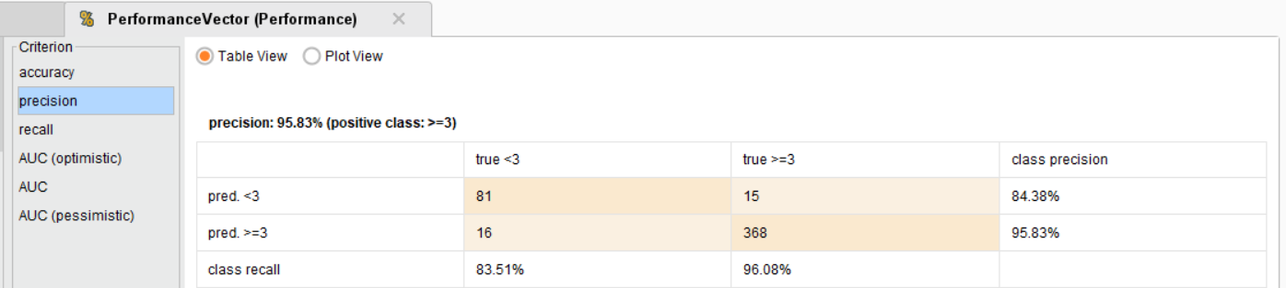

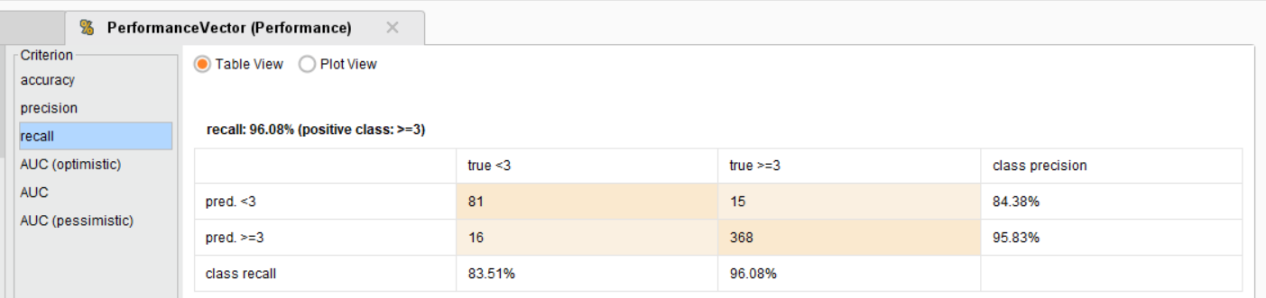

Q2(Naive Bayes Kernel)

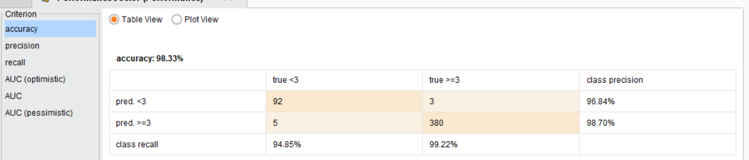

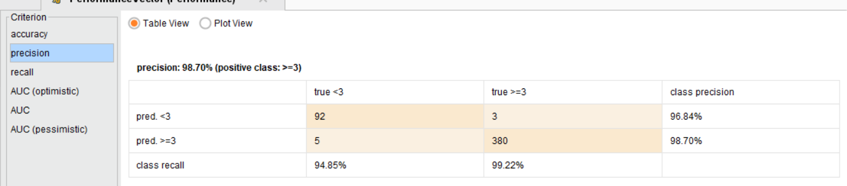

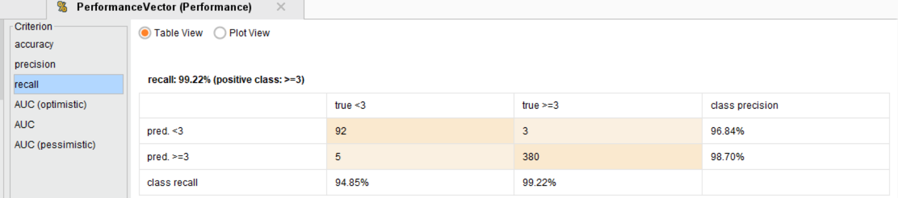

Q3(Naive Bayes)

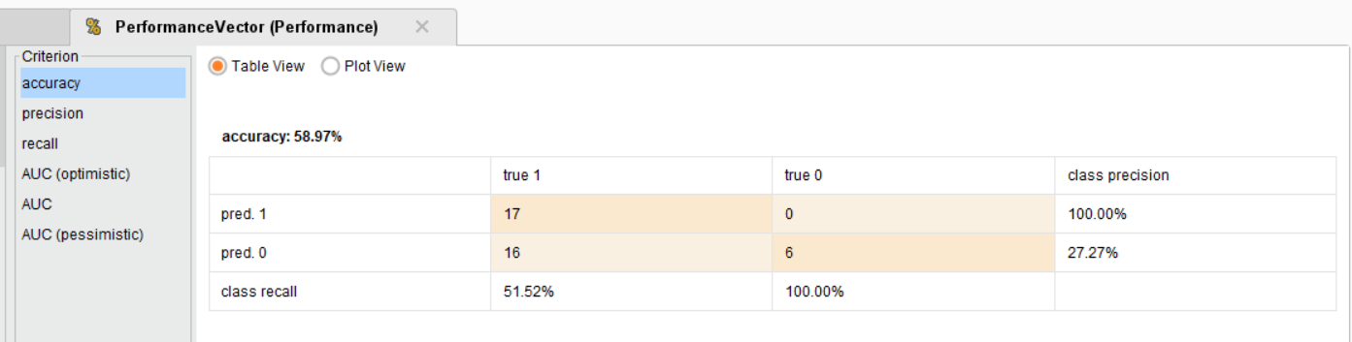

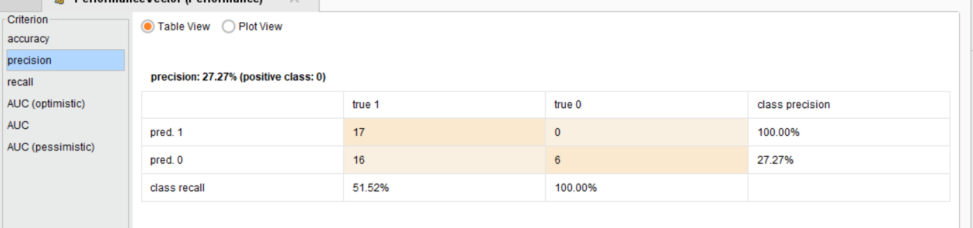

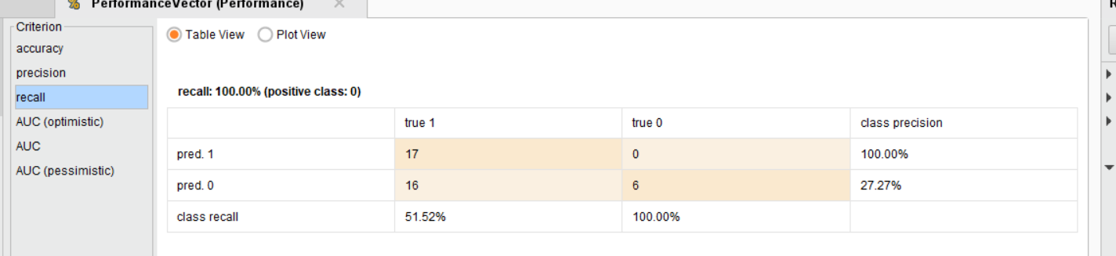

Q3(Naive Bayes Kernel)

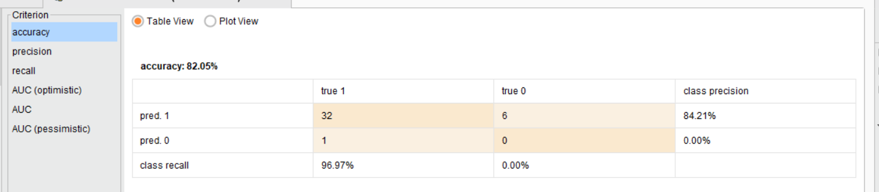

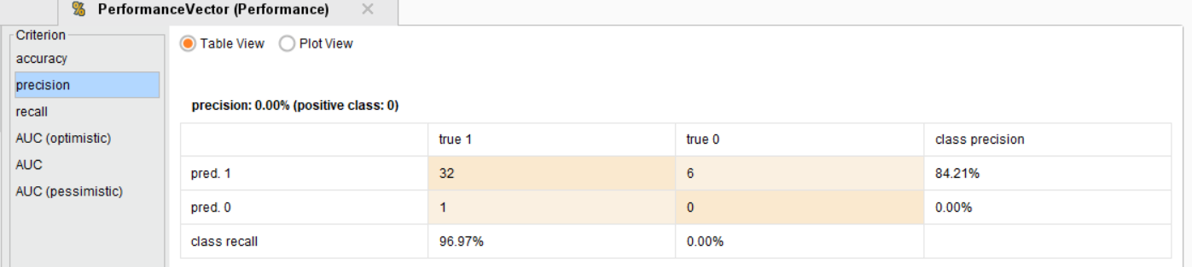

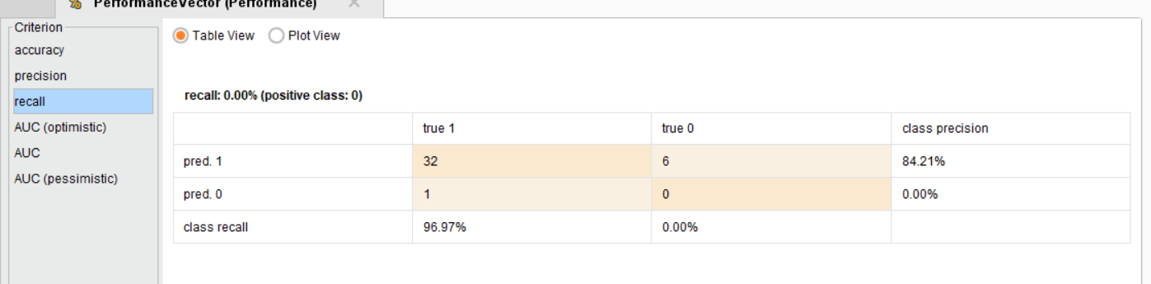

Q4(KMEANS)

